Presented (poster) in 2013 IEEE International Conference on Emerging & Sustainable Technologies for Power & ICT in a Developing Society (NIGERCON)
Design of State Feedback Controller for Inverted Pendulum

N Magaji
Department of Electrical Engineering
Bayero University, Kano
Kano -Nigeria
nmagaji2000@gmail.com&

A. Dan-Isa,, A U Lawan and Mukhtar Fatihu Hamza
Department of Electrical Engineering
Bayero University, Kano
Kano -Nigeria

Abstract— This paper, present the design and simulation of a complete control system for the stabilization of an inverted pendulum using state feedback algorithms The full-state feedback controller was first design on the assumption that the entire state vector is available for feedback. The state feedback controller was designed based on the following requirements, Settling time, Rise time, peak overshoot and steady state error. The power of modern state-space techniques for the analysis and control of Multiple Input Multiple Output (MIMO) systems is also investigated using MATLAB/SIMULINK. This simulation environment supports the development of real time applications in an easy way.
Key words-- Cascade control, Feedback linearization Inverted pendulum, and State-feedback control.)

Introduction (Heading 1)
The process used in this project is the inverted pendulum system. Being an under-actuated mechanical system and inherently open loop unstable with highly non-linear dynamics, the inverted pendulum system is a perfect test-bed for the design of a wide range of classical and contemporary control techniques [1, 9]. Its applications range widely from robotics to space rocket guidance systems. Originally, inverted pendulum and similar systems were used to illustrate ideas in linear control theory such as the control of linear unstable systems [3]. Their inherent non-linear nature contribute in maintaining their usefulness through the years and they are now used to illustrate several ideas emerging in the field of system identification, modern control, non-linear control, fuzz fuzzy logic and neural networks [1,4].
A Single rod Inverted Pendulum (SIP), consists of a freely pivoted rod, mounted on a motor driven cart. With the rod exactly centered above the motionless cart, there are no sidelong resultant forces on the rod and it remains balanced [5]. In principle it can stay this way indefinitely, but in practice it never does. Any disturbance that shifts the rod away from equilibrium, gives rise to forces that push the rod farther from this equilibrium point, implying that the upright equilibrium point is inherently unstable as described by reference [5]. Under no external forces, the rod would always come to rest in the downward equilibrium point, hanging down similarly described by reference [6,7]. This is called the pendant position. This equilibrium point is stable as opposed to the upright equilibrium point. The control task is to swing up the pendulum from its natural pendant position and to stabilize it in the inverted position, once it reaches the upright equilibrium point. The cart must also be homed to a reference position on the rail. All this is achieved only by moving the cart back and forth within the limited cart travel along the rail.
This paper comprises of five major sections: Section 1 introduces the classical control problem of Inverted Pendulum. Section 2 explores the mathematical model of the Inverted Pendulum System and their simulink models. Section 3 explores the pole placement techniques method for designing the required controller for the Inverted Pendulum System. Section 4 presents some simulation result and compares with PID control approach. And finally several conclusions are drawn in last section

MATHEMATICAL MODELLING OF INVERTED PENDULUM
The cart is driven by a DC motor, which is controlled by a controller. The carts x position and the pendulum angle are measured and supplied to the control system. A mathematical model of the system has been developed, giving the angle of the pendulum resulting from a force applied to the base

Non-Linear Dynamic Model
Referring to Figure 1 and applying Newton’s 2nd law at the centre of gravity of the pendulum the horizontal and vertical components yield

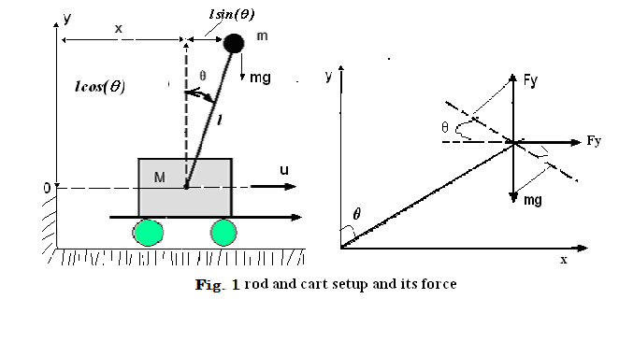
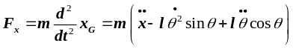 (1)
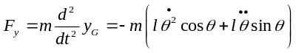 (2)
This gives below equation after simplification
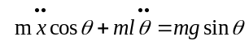 (3)
and
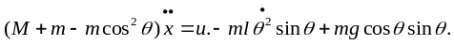 (4)
From (4)
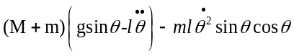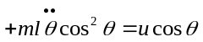 (5)
And
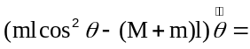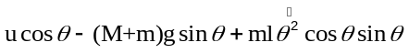 (6)
Finally equation 4 and equation 6 gives
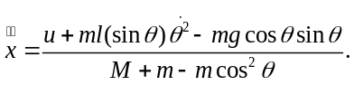 (7)
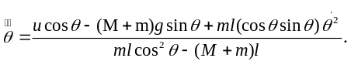 (8)
Where M; is mass of the cart; m is mass of the rode ;l is length of the rode; horizontal force on the cart =u , acceleration due to gravity =g ; gravity force on m = mg position of cart=x (t); tilt of the rod=Ө(t) and center of gravity of point mass m= x_{G}, y_{G})
The above equations are reducing to the simulink model shown in fig. 2 though it is more complicated. It is possible to encapsulate it in subsystem block fig.3b.

Linearized Model In State Space
Equations (7) and (8) were used to model the open-loop inverted pendulum system. However, for the design of the linear state-feedback controller, we need a linearized version of these equations
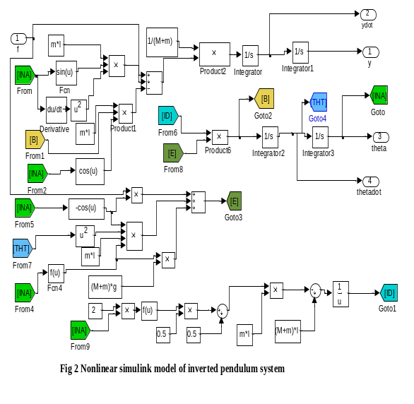

The inverted position of the pendulum corresponds to the unstable equilibrium point (θ,) = (0,0). These corresponds to the origin of the state space, in the neighborhood of this equilibrium point, both and are very small (in rad & rad/sec respectively). In general, for small angles of θ and 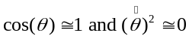using these approximations in (7) and (8), the mathematical model linearized around the unstable equilibrium point of the inverted pendulum is obtained, and given
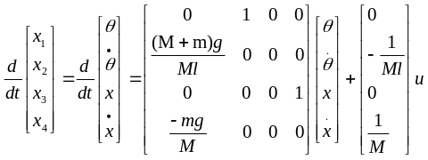 (9) 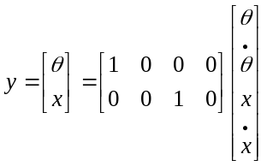 (10)

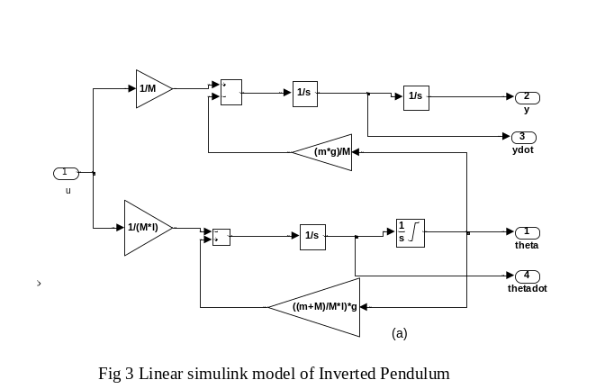

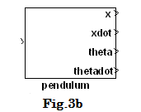

SYSTEM DESIGN
The full-state feedback controller stabilizes the system by positioning the closed loop poles in the stable region. The controller was designed based on the following requirements: (i) settling time of less1.5 second. (ii) Pendulum angle never more than 0.1 radians from the vertical position (iii) Rise time approximately 0.4 second To meet these specifications, the closed loop poles were placed at s=μ_{i} (i=1,2,3,), Where μ₁ and, μ₂ are dominant closed-loop poles 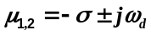The other two poles are located far to the left of the dominant pair of closed 0loop poles and are given as μ₃= -5 and μ₃=-6. Base on these poles a matlab function place was used to get the controller matrix Ks
The simulink block of the state feedback controller plus plant model is shown in Fig.4.
Nr is a gain required to reduce the steady state error to zero which was obtain from the formula 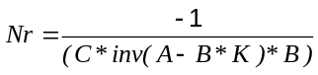
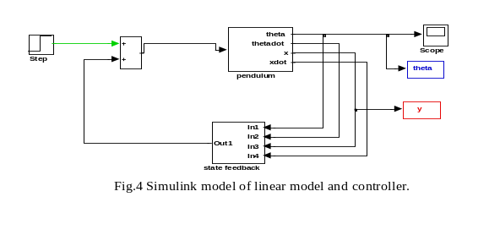

RESULT OF SIMULATION

Figure 5 shows the angle of the pendulum for open loop system, the simulation result shows that the pendulum goes unstable and falls over. Fig.6 shows the state feedback controller stabilized system by keeping the pendulum angle stable. The pendulum can be simulated for longer times. The response of cart position is shown in figure 7 which indicate stable position with stat feedback regulator. Final response is figure 8, PID response of pendulum position which quite slower compared with figure 6.

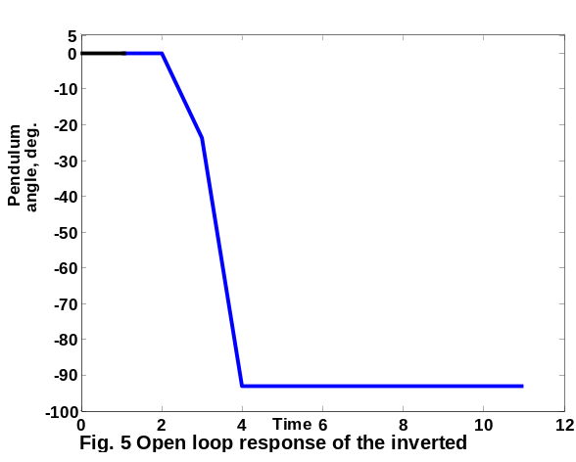

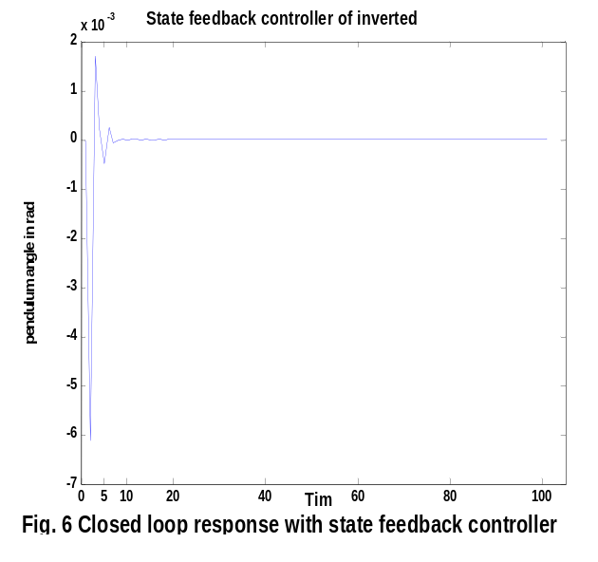

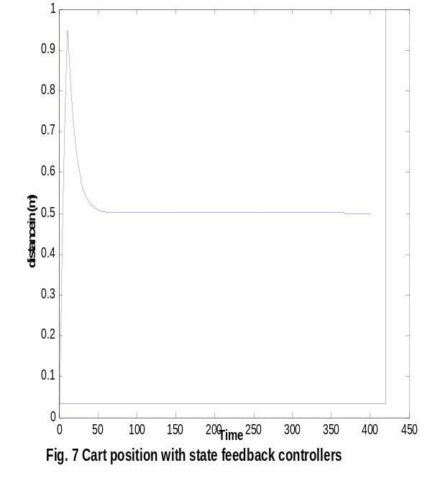

Prepare Your Paper Before Styling
Before you begin to format your paper, first write and save the content as a separate text file. Keep your text and graphic files separate until after the text has been formatted and styled. Do not use hard tabs, and limit use of hard returns to only one return at the end of a paragraph. Do not add any kind of pagination anywhere in the paper. Do not number text heads-the template will do that for you.
Finally, complete content and organizational editing before formatting. Please take note of the following items when proofreading spelling and grammar:

CONCLUSIONS
The results presented in Section 4 verify that the system designed and implemented in this paper was successful. The control task stated in Section 2 was completely fulfilled, i.e. the pendulum swung-up from its natural pendant position according to the algorithm developed in [1] and stabilized in the inverted open-loop unstable position using state-feedback pole-placement. The cart also homed back quickly to a reference position on the rail.

REFERENCES
[1] Bugeja, "Non-linear swing-up and stabilizing control of an inverted pendulum system,"
[2] Friedland, Bernard. (1987), Control System design, New York: McGraw-Hill, pp 30-52
[3] Johnny Tang and Hamid Shoaee “A Comparative Study of Fuzzy Logic and Classical Control with EPICS”
[4] Ljung, L. System Identification-Theory for the User, second edition. Prentice Hall 1999.
[5] Marvin Bugeja, “Non-Linear Swing-Up and Stabilizing Control of an Inverted Pendulum System” Proceeding of EUROCON Computer as a Tool 2003 Ljubljana, Slovenia, volume 1.
[6] Application Examples of the KRi Inverted Pendulum PP-300 www.kri.com.sg/ip300.pdf
[7] Ashab Mirza, and Sarfraz Hussain, “Robust Controller for Nonlinear & Unstable System: Inverted Pendulum”, AMSE Journal of Control & Design Simulation, pp 49-60, Vol. 55, No 3, 4. 2000. [www.amse-modeling.org]
[8] Katsuhiko Ogata, "Modern Control Engineering," Second Edition. 1990
[9] Rybovic, A. “Control of the inverted pendulum using state feedback control” proceedings on 9th International Conference - 2012 elektro, slovakia May 21 - 22, 2012 [10] CTM Example: Inverted Pendulum Modeling

